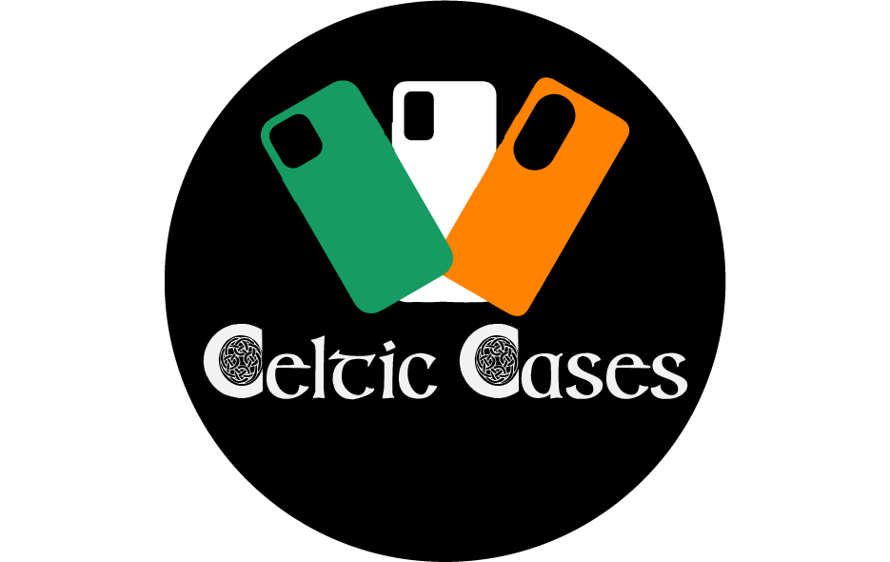

Final Document
Keith Thornton | Professional Practice in IT | 23/04/2022 | https://celticcases.net/

Table of Contents
Background 3
Content 4
Navigation 5
Links & Logo 5
Shopping Cart 5
Footer 5
Home Page (index.php) 6
Samsung Page (samsung.php) 7
iPhone Page (iphone.php) 8
Huawei Page (huawei.php) 9
About/Contact Us (contact_us.php) 10
Checkout Page (checkout.php) 11
Theme 12
Logo 13
Technologies & Software used 15
Conclusion 15

Background
This project was undertaken to test my skills as a web developer and to try and create a working website for a side-business, selling phone cases and console skins online. As I was the customer for the website this proved to have its benefits along with some pitfalls which I will elaborate on later.
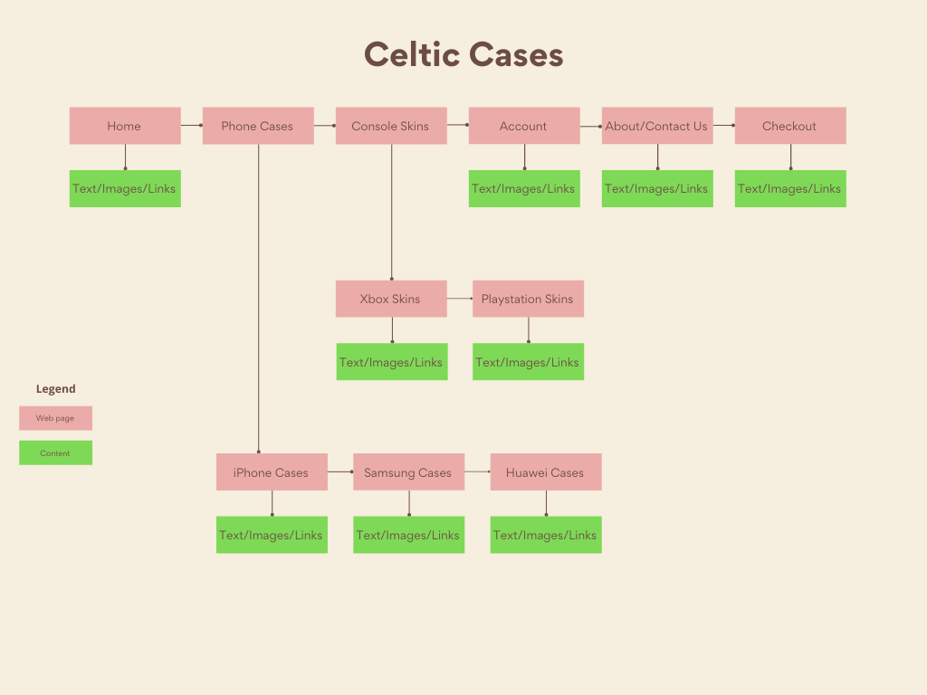
The premise of the project was to create a website that consisted of seven web pages. They were as follows:
- Home
- Phone cases
- Console Skins
- Account
- About/Contact
- Checkout
During development the choice was taken to reduce some of the pages due to a few factors. These reasons were as follows:

- The war in Ukraine and financial sanctions imposed on businesses worldwide caused a major backlog in importing stock from China in an already struggling market due to covid-19. Due to this I was unable to acquire console skins, and certain phone cases except for dealer samples. For this reason, I chose to focus on phone cases and create three sections for the different phone types.

- The ecommerce php system of the website proved to be quite complex and it was due to this that I chose to drop the account section of my website and focus on the stock and shopping cart features, in terms of having my website work with a database.

After the above decisions were made the website layout consisted of the following pages:

- Home
- Samsung cases
- iPhone cases
- Huawei cases
- About/Contact
- Checkout

Content

The content of the website consists of HTML forms, lists, images, links, and buttons with php functionality. The Bootstrap 5 framework was used for ease of styling and as the base of the navigation bar. All pages are of php file type to facilitate the use of php sessions and carry over the current shopping cart status to each page of the website. The website is fully responsive, and securely hosted with SSL certification.
Below is a breakdown of the content for each page of the website.

Navigation
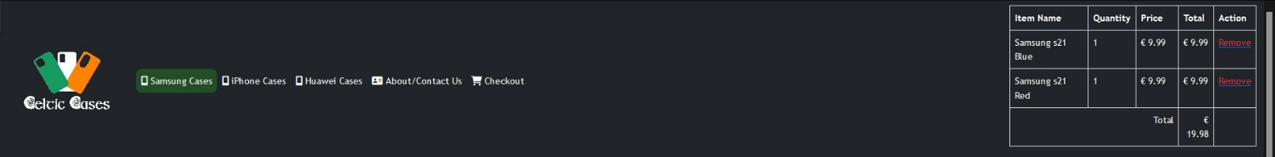

Links & Logo
The navigation bar of the website features clickable links that are as follows:
- Home
- Phone cases
- Console Skins
- Account
- About/Contact
- Checkout
Each link has the following features:
- Displays current page by way of a green border box around the current page the user is on.
- Displays a bright green colour around each link on hover
- Has an icon representing the page type e.g., Shopping cart icon for Checkout page.

The navigation bar also displays an animation of the company logo, that when clicked redirects the user to the home page.

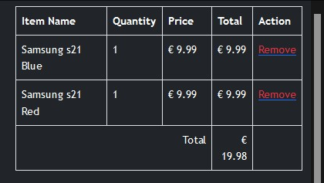

Shopping Cart
I embedded the shopping cart functionality into the navigation as well as in the checkout page. This shopping cart was created using php and html tables. The table is directly linked to the product cards by way of a html form. The shopping cart displays the current items in the basket along with the individual and total price.

Footer
The footer of the website consists of an alternate company logo, social media links and a link to the contact section of the website

Home Page (index.php)

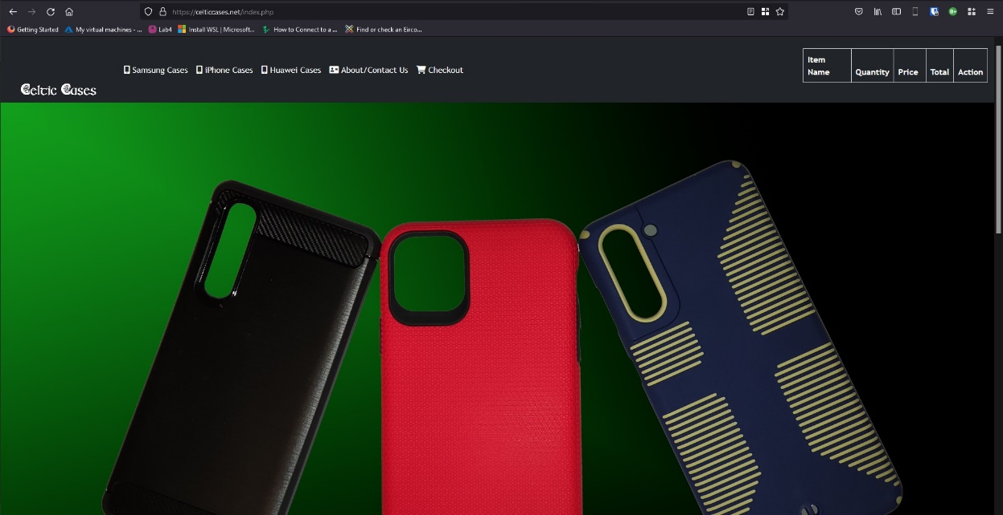

Index.php is the home page for Celticcases.net. This is the landing page for the website but can also be accessed by clicking on the company logo in the top right corner. This page features a large image of three phone cases of different phone types along with the colour theme of black and green in the background. This image includes some text with the company motto. These images were taken by me, edited, and combined in photoshop.

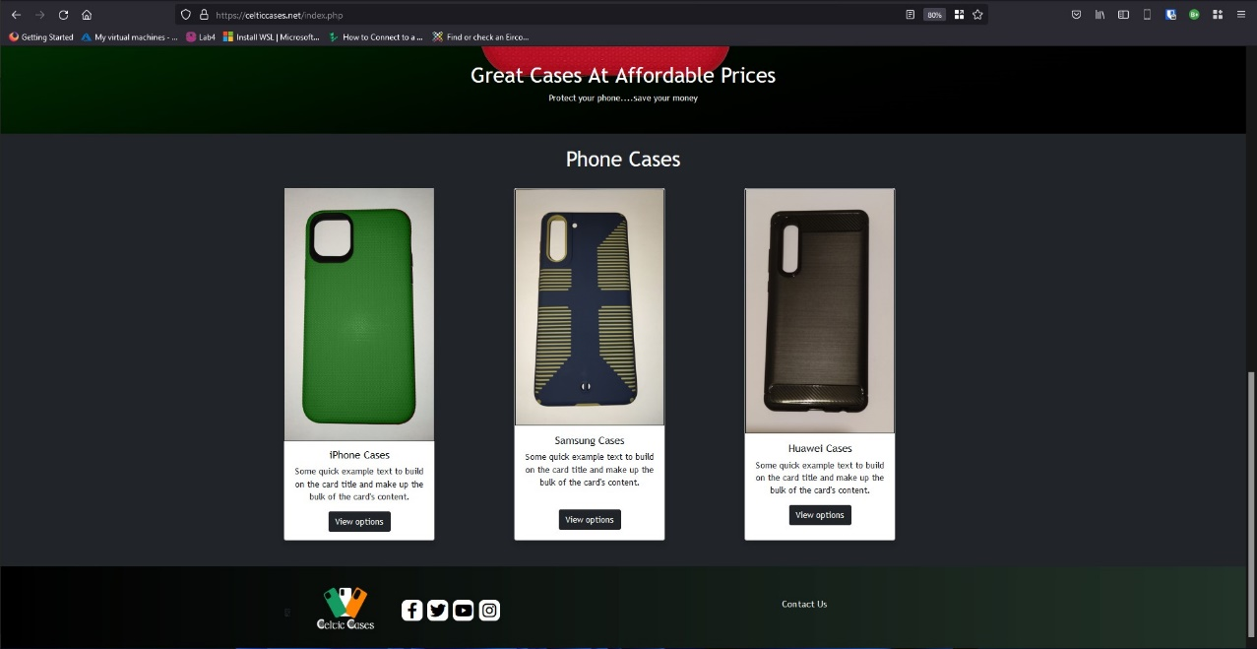
Below the main image are three product cards displaying the three different case types that are available on the website along with a short description and a button that when pressed will take the use to the relevant page they wish to access.

Samsung Page (samsung.php)

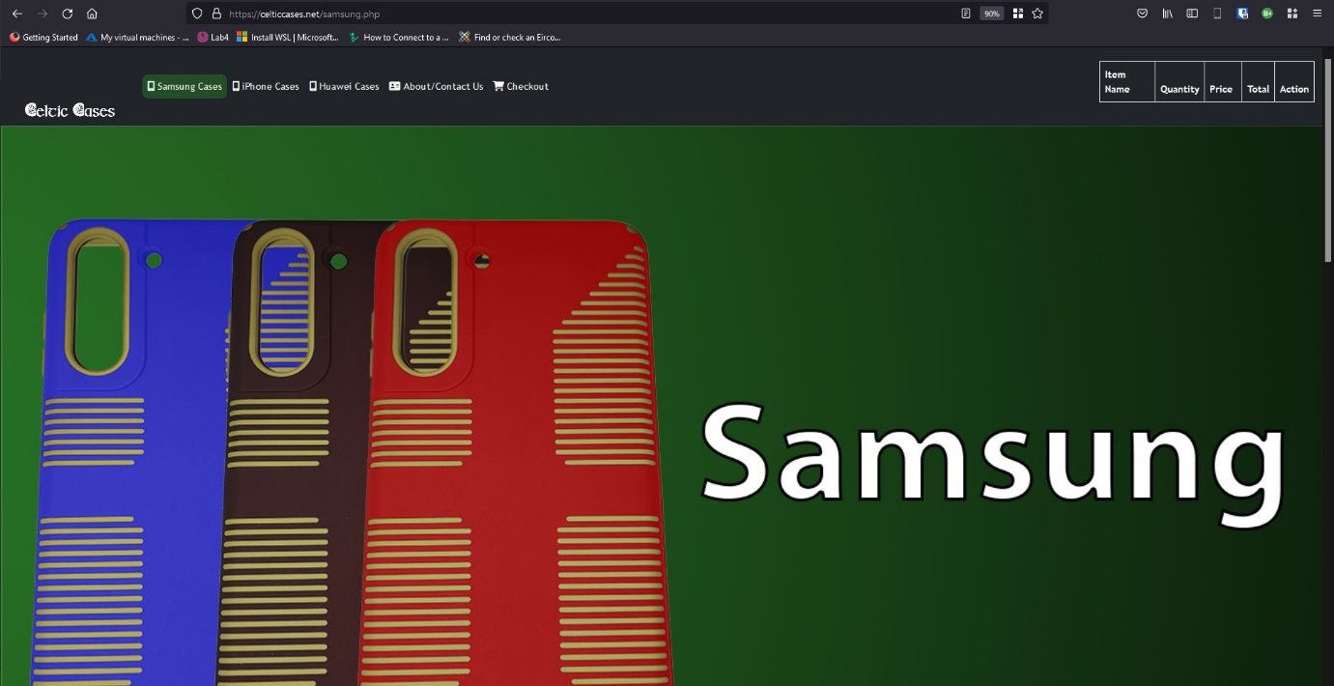
Samsung.php consists of a large still image of three Samsung phone covers along with the company colour scheme of green and black. There is also some large text on the image identifying which phone case type the user is looking at.

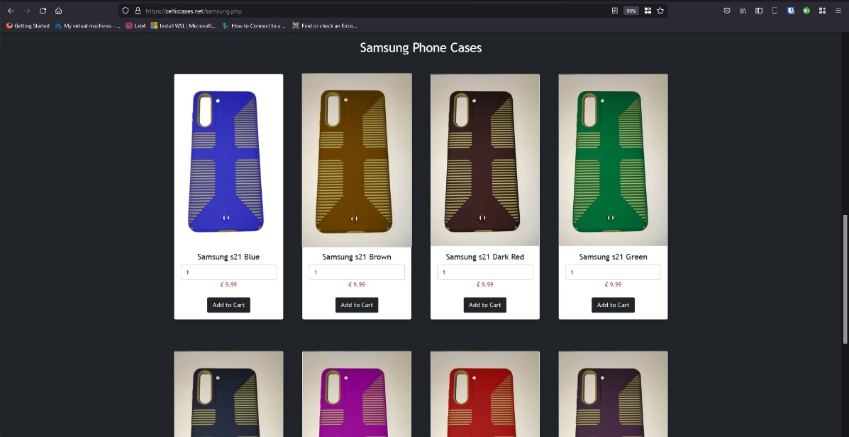
Below is a list of product cards displaying the current list of products available for that case type. There is also a description of each phone type, price, quantity, and an “add to cart” button.
The phone image, description and price are all displayed on these product cards using PHP and a mysqli query that cycles through the stock database for that case type and fetches these values and displays them in sequence. This way any changes, such as adding or removing stock in the database will automatically reflect on the website page, this reduces the need to do this manually using html.

iPhone Page (iphone.php)

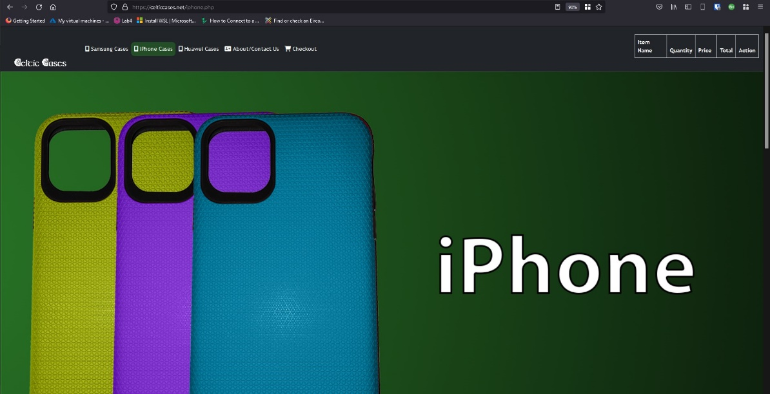

Iphone.php follows the same format as Samsung.php however the product cards on this page are pulling their information from a different table in the database.

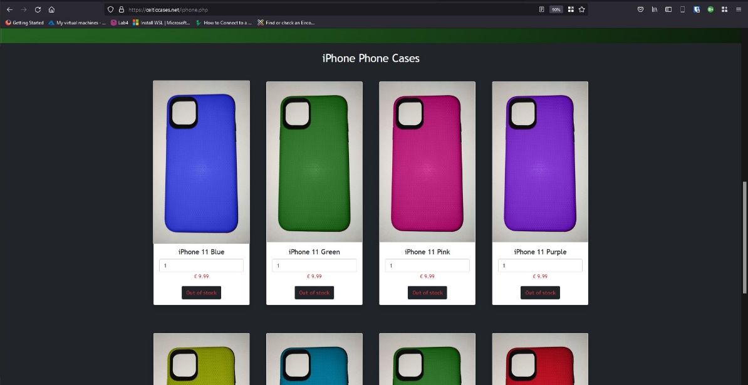

As I was only able to acquire one sample case from the company I was dealing with, I chose to use photoshop and create multiple different images of different case colours for this section. The phones on this section are listed as out of stock with a non-clickable button

Huawei Page (huawei.php)
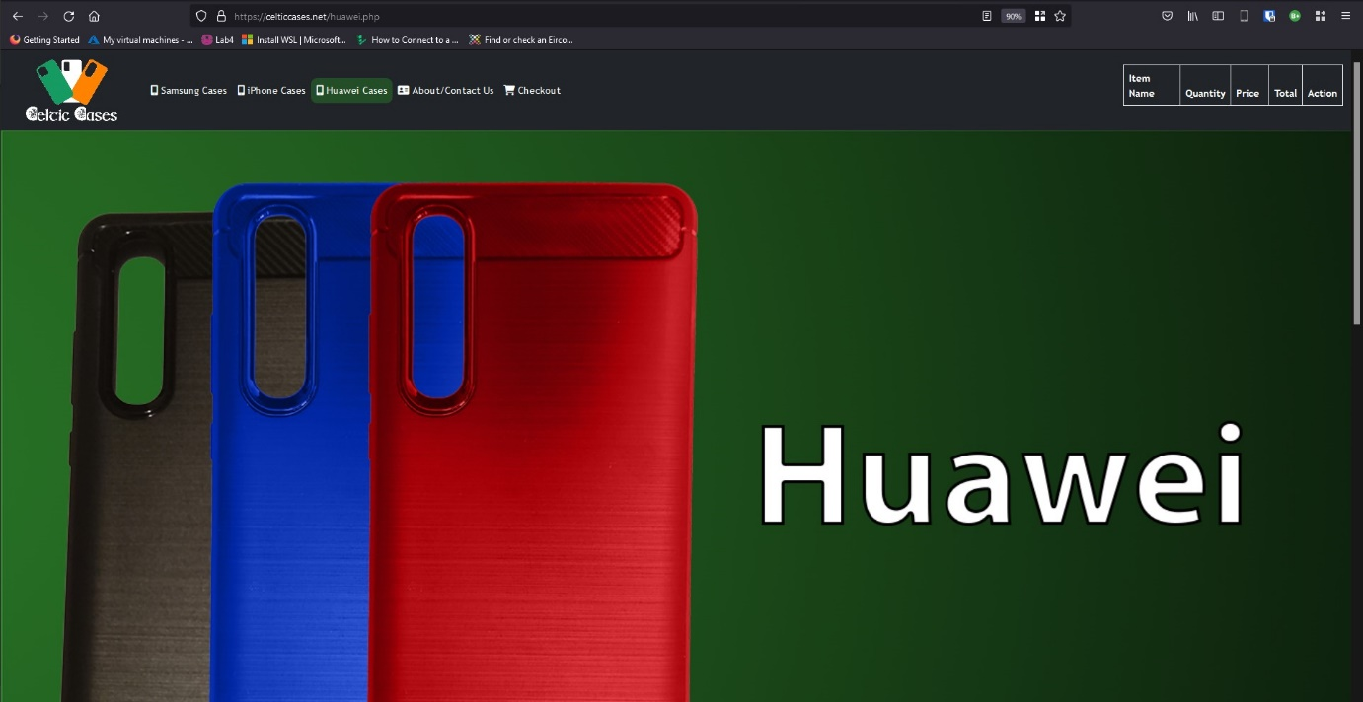

Similarly, as described in the previous page I was only able to acquire a sample phone case for this section and decided to make two alternate colour types in Photoshop. These products are listed as out of stock too.

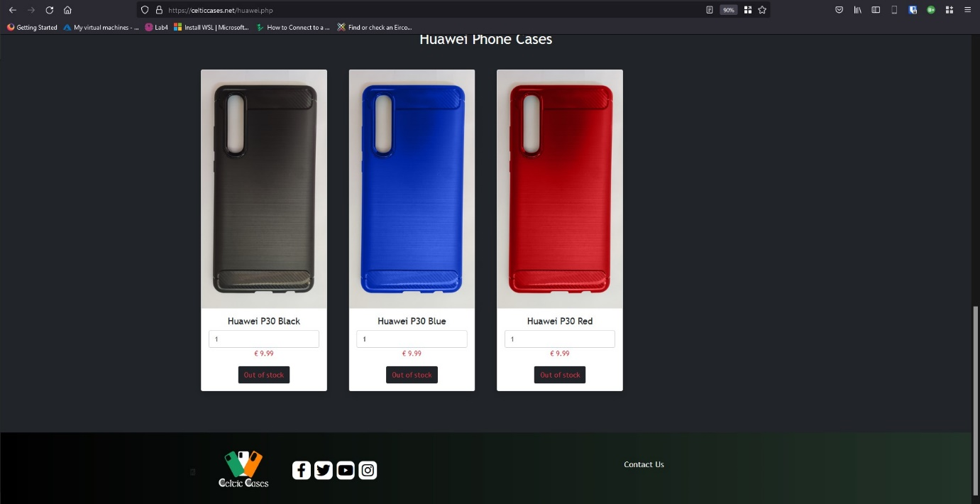

About/Contact Us (contact_us.php)

Contact_us.php features a HTML contact form that when filled out by the user allows them to create a message for any query they may have. When submitted, this information is sent to the company email address.
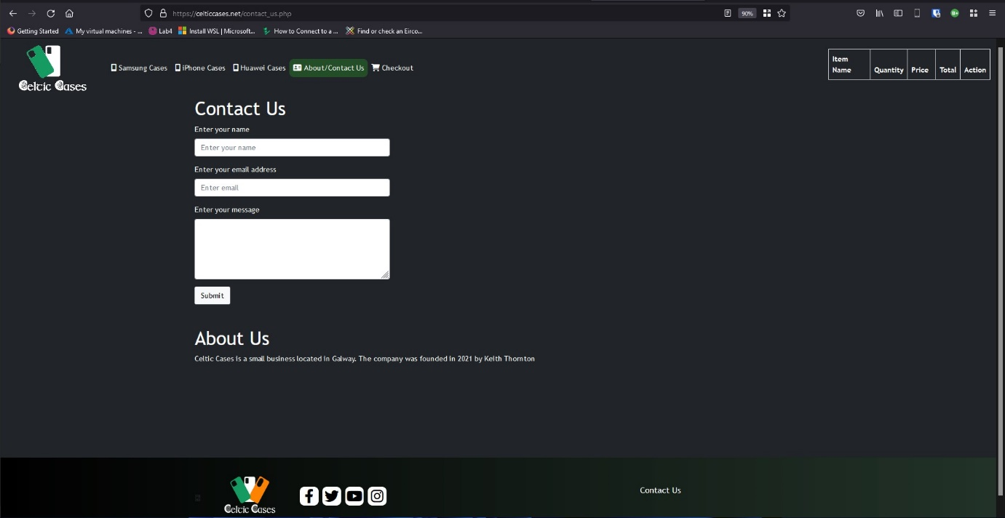
Below this is a brief description of when the business was founded, who runs the business and where it is based.

Checkout Page (checkout.php)

The checkout section of the website features the shopping cart function that is displayed in the navigation of the other pages. This shows the customer the total breakdown of the items they have in their shopping cart. This functionality is working using PHP code.

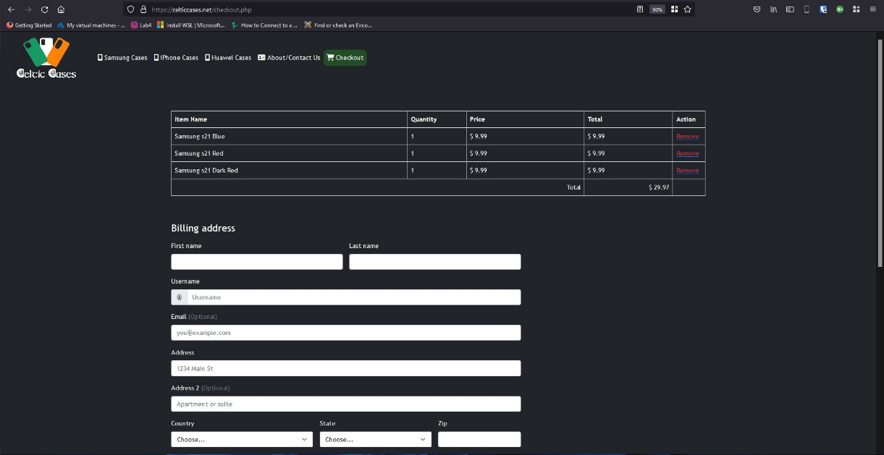

Below this is a html form which displays the billing and payment details which the customer must input. This section is not connected to the shopping cart, as linking the shopping cart to a service like Stripe or similar service had the following challenges: It required me to have an actual business; it was too costly; the code for this functionality was quite complex and I didn’t have sufficient time to implement this feature due to the problems I encountered as mentioned in the conclusion below.

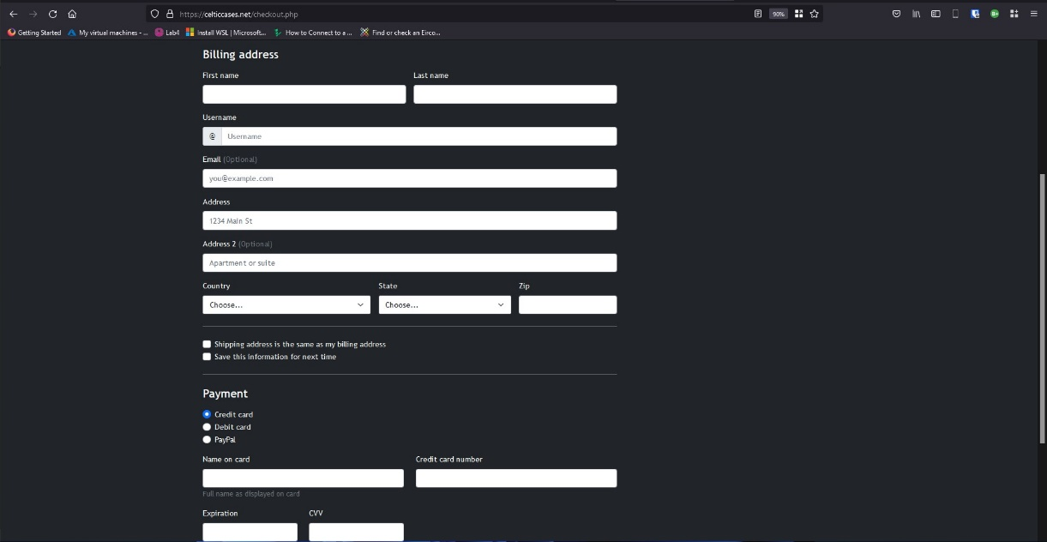

Theme
The colour theme of the website that was chosen for the website are as follows:
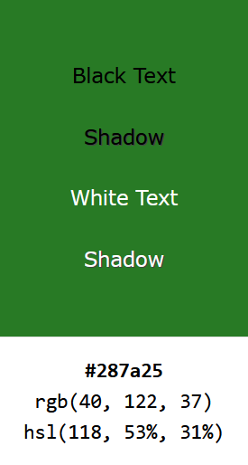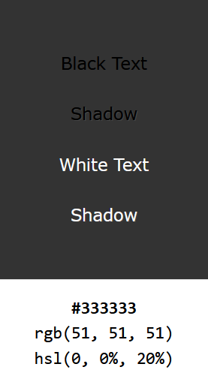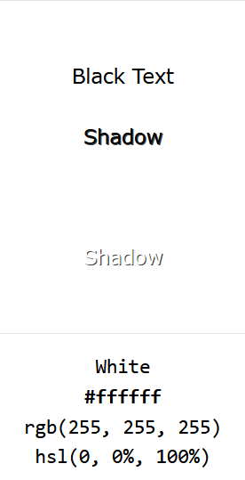
The above colours were chosen to give the website a unique feel and green was used to represent the Celtic theme.

Logo

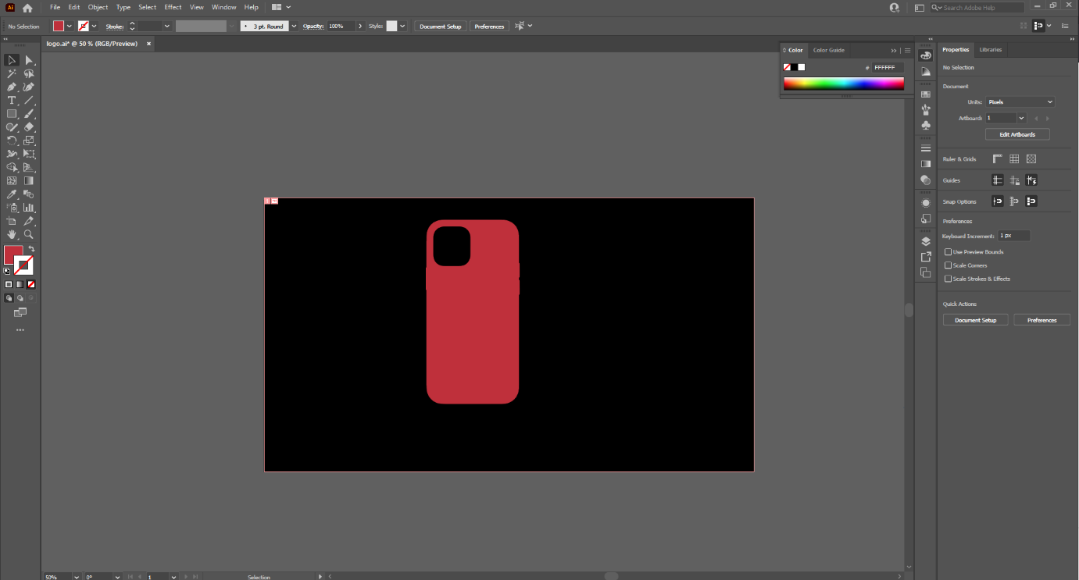

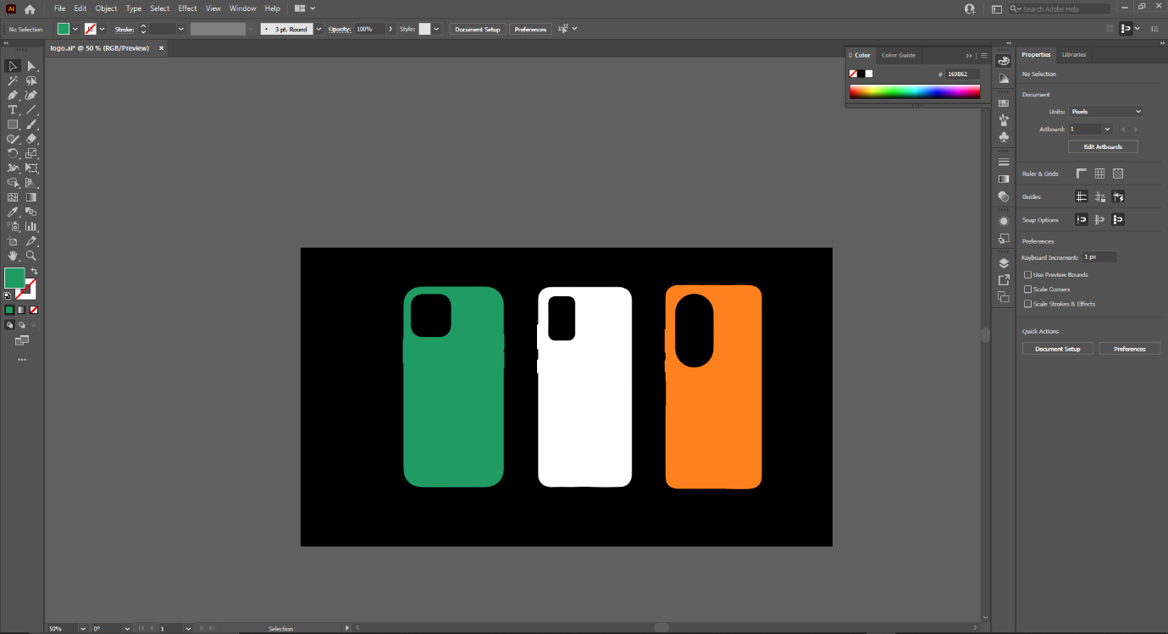
The logo for the business was designed using mostly Adobe Illustrator. The process I used was image tracing images of real phone cases, creating individual PNG images of each phone case and bringing each image into a final image together.

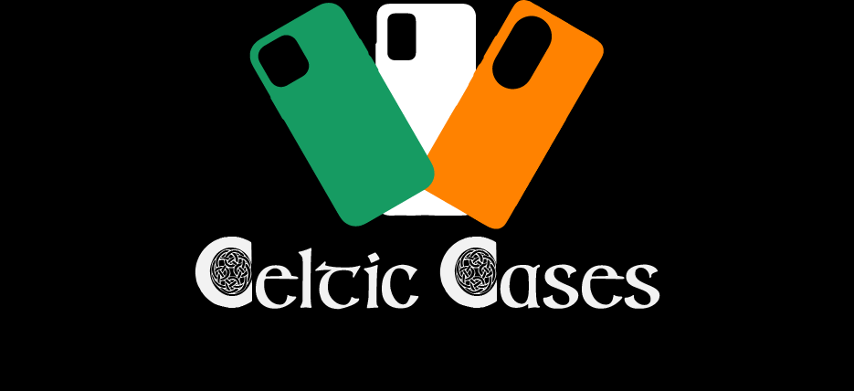
The logo that was chosen is an image of three phone covers angled away from each other in the pattern of the Irish tricolour.

Alternate image of logo with black background.

Technologies & Software used

The following technologies and software were used to develop and manage the website:
- HTML
- CSS
- Bootstrap
- JavaScript/Typescript
- SQL DBMS
- MySQL
- Visual Studio Code
- Adobe Illustrator
- Adobe Photoshop
- Namecheap (hosting service)

Conclusion

As I mentioned above in the background section, I was the developer and the customer for this project. These are a some of the pros and cons I encountered in this situation:

Pros
- Full creative control.
- Ability to work at my own pace.
- No meetings with customer.

Cons
- Having to spend a lot of time conceptualizing how the website and its overall layout would look.
- Having to source my own products.
- Often wasting time on certain sections of the website that would have otherwise been deemed less important by the customer.
- Lack of direction.

There were many issues when developing this website. Firstly, I have shouldn’t have chosen an ecommerce-based website as the php code required to handle the functionality was quite complex and beyond anything I have learned thus far. Due to this I feel that the styling of the website suffered somewhat and if I had more time, I would have liked to have improved on this. However, it did force me to learn new concepts and I have come out of this project with a better understanding of what is required in terms of planning, development, time management and limitations.

